Circles of Control

Introduction

This activity is good for children and young people who are struggling with lots of worries. Your child might not know how to express these worries to you or you might not know how to go about starting to talk about them with your child. This activity might help you both to address these.

The activity starts using the end of the story ‘Huge Bag of Worries’. The old lady helps the main character Jenny to sort out her worries. Jenny sorts them into those that belong to Jenny, those that belong to people in her family and those that everyone has.

Start of the activity

Copy the link into your web browser and watch the 4.5min story.

https://www.youtube.com/watch?v=NbcswBYnmeQ

Next…

Find something to write on, draw one big circle and another smaller one inside the big circle. Label the inside circle as ‘worries that belong to you’ and the big circle with ‘worries that belong to other people’.

Worries everyone has
Other people’s worries

Your worries
Worries everyone has
Worries everyone has
Worries everyone has

We don’t have much money

The house is going to flood

I’m not doing very well at maths

I worry about sleeping in the dark

Worries everyone has
Other people’s worries

Your worries
Worries everyone has
Worries everyone has
Worries everyone has

Model writing down some of your worries, once you have done this put them in the different parts of the circle according to who they belong to.

Help your child write down or draw their worries and then sort them, removing yours from the circles

Finally…

Look at the worries that belong to other people and do something with your child to help them to stop worrying about these
Blow feathers
Fold paper aeroplanes
Create worry people

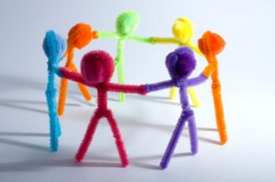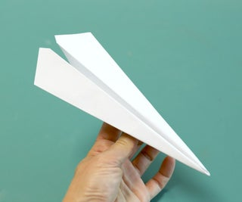

Make paper aeroplanes, write the worry on the plane and then throw the aeroplane as far as you can, throwing the worry away.

Hold a feather tight in your hand and image giving the worry to the feather. The with the biggest puff of air you can manage blow it off of you hand and with it the worry.

Make pipe cleaner people, whisper the worry to the pipe cleaner person and then give the pipe cleaner person to a trust adult.

Helping to solve your worries…

Understanding how worry feels
First it would help for your child to understand what the worry feeling feels like.

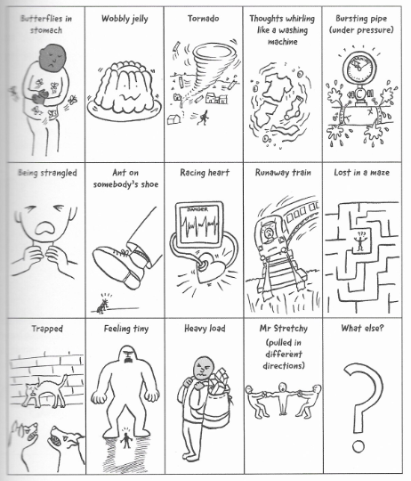
Image taken from Dr Karen Treisman Binnie and the Baboon

Understand where worry is in your body
Next it helps to understand where the worried feeling feel is in the body and other feelings such as calm and happiness

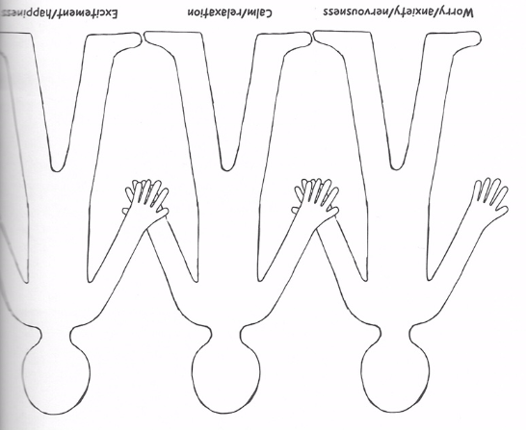

Image taken from Dr Karen Treisman Binnie and the Baboon

You can be super creative and cut out paper people, decorate them and then mark where worry, calm, and happiness feels on each paper person for you.

Understanding triggers and warnings
It can also help to talk, draw about triggers and warning signs. You could ask questions like;

Who are the people that make the worry visit?

What places, sights, objects or things that I can see make worry visit?

Situations that make the worry visit?

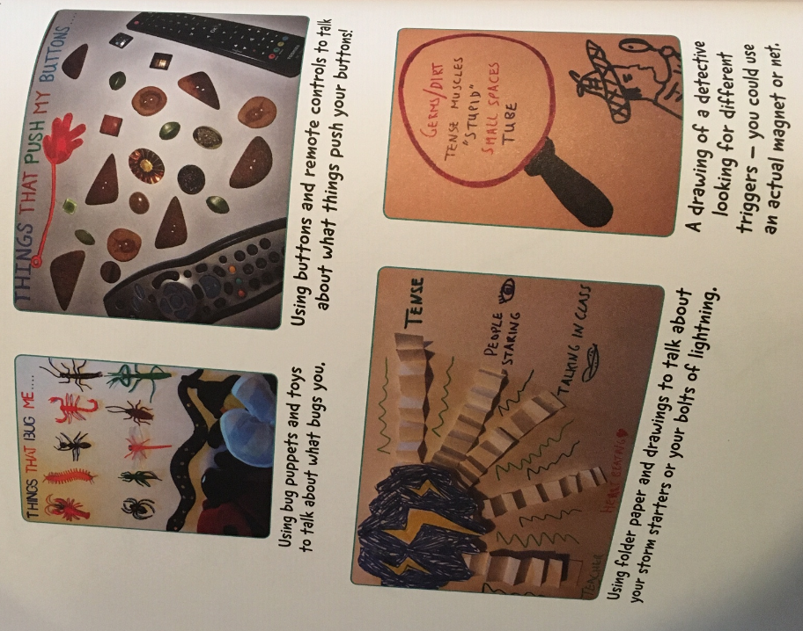
Image taken from Dr Karen Treisman Binnie and the Baboon

Once you have got some of the answers to these questions you can help you child before these situations come up. You can talk to them about we are going to/going to see… I know that these make you worry we will do this, this and this to make it better.

You can also use lots of the other ideas on our website to help feel calm and regulated

https://www.somersetphoenixproject.org.uk/creative-resources

