**Somerset Phoenix Project**

**Information Guide for Parents and Carers**



**Working alongside professionals and supporting children, young people and families affected by sexual abuse**

[](http://www.google.co.uk/url?sa=i&rct=j&q=&esrc=s&source=images&cd=&cad=rja&uact=8&ved=0ahUKEwia3v7CtavUAhUQlxQKHXNwCuIQjRwIBw&url=http://www.sarsas.org.uk/&psig=AFQjCNFX4fjxSGw3J66VZYdAdyHHN8ttxQ&ust=1496914046189545)[](http://www.chard.gov.uk/services/somerset-county-council/)

**This booklet has been produced by the Somerset Phoenix Project to provide you with some background information and practical ideas on how to help your child or children recover from childhood sexual abuse.**

**We hope that you find it useful and please feel free to contact us for further advice.**



**Contents**

|  |  |
| --- | --- |
| Introduction | P4 |
| Somerset Phoenix Project | P6 |
| Sexual Abuse | P7 |
| How Does Sexual Abuse Affect Children / Young People? | P10 |
| Why Does This Happen? | P13 |
| The Science Behind Survival Mode: Friend, Fight, Flight, Freeze, Flop | P15 |
| The Tip of the Iceberg | P18 |
| Your Child’s Relationship with the Abuser | P19 |
| Practical Tips to Help your Child | P21 |
| Other Things to Remember | P25 |
| Supporting Your Child | P27 |
| How does Sexual Abuse Affect a Parent/Carer | P30 |
| Effects on Family and Friends | P33 |
| Parental Support – Looking after Yourself | P36 |
| Nurturing Your Child | P39 |
| Useful Video Clips | P40 |
| The Court Process, Preparing for Court, Giving Evidence and Post Trial | P44 |
| Useful Links for Court Information | P51 |
| Supporting Your Child / Young Person During a Police Investigation / Trial Process | P52 |
| Useful Contacts | P53 |
| Useful CSA Terms and Acronyms | P57 |
| Phoenix Contact Information | P62 |

**Introduction**

As a parent/carer, finding out that your child has been sexually abused is one of the worst experiences you can have. It can be frightening, overwhelming, confusing and traumatic. You will go through many of your own difficult feelings.

Child sexual abuse (CSA) affects not only your child and you as a carer but all members of the family too. Family and friends are also often left with and show a confusing array of different emotions, responses and reactions. These responses and reactions may put a strain on relationships.

The effects of sexual abuse on a child can be severe and long lasting. We know that parents and carers can play a powerful and effective role in helping their child or children heal from the trauma of the abuse they have experienced. We also know that as a parent you will need support for yourself too.

This booklet has, therefore, been written to offer you:

* some information about child sexual abuse
* what you might expect from your child
* how you can begin to help them recover
* what feelings you may experience
* how you can look after yourself and why this is important
* how you can manage emotions towards the perpetrator

Some of the sections within this guide may be distressing and hard for you to read. These potentially distressing sections are marked with a \* at the start and end of the title. There is a self-care section in this guide called ‘Parental Support – Looking After Yourself,’ page 36. If you find a section distressing, please jump to this part of the guide.

Please take care of yourself when reading this guide. Read it at your own pace and in your own time.

**“The Somerset Phoenix Project has offered invaluable support for my daughter at this difficult time”**

**“Knowing that my daughter has someone she feels relaxed around and to confide in people other than myself provides me with great solace”**

**“Prior to Phoenix involvement there were times when I felt isolated and unsure of the best way to approach my child’s troubled behaviour. Phoenix has provided excellent coping strategies with the tools to help at home to manage the feelings. I am thankful for your input.”**

**Somerset Phoenix Project**

The Somerset Phoenix Project is a **specialist support service for children and young people living in Somerset, aged 5-18, and their families, who have been affected by childhood sexual abuse (CSA).**

The Phoenix Project is here to support professionals, parents/carers and children/young people to reduce the negative impact that CSA has on the lives of children and families living in Somerset by:

* offering support, training and signposting to professionals who are supporting children and young people affected by CSA
* supporting parents and carers via information sharing (such as this service guide) and peer support
* providing support to children, young people and their families to help them move on emotionally after their experience of abuse

It is important to highlight that we are a recovery service. This means that if the abuse is on-going or if there are still high levels of risk and concern you may need to be supported by a different service such as The Bridge or Safelink – see contacts section – in the first instance.

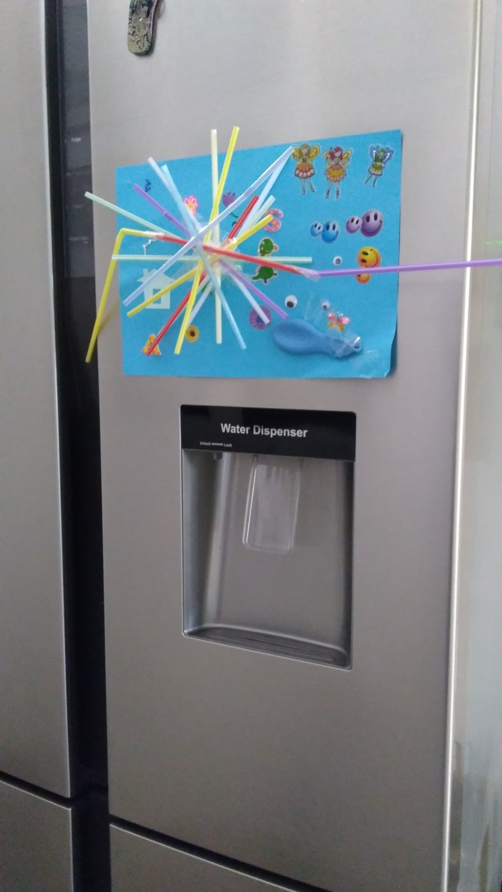

**\*Sexual Abuse\***

**What is sexual abuse?**

A child is sexually abused when they are forced or persuaded to take part in sexual activities. This doesn't have to be physical contact and it can happen online. Sometimes the child won't understand that what is happening to them is abuse. They may not even understand that it is wrong.

There are two different types of child sexual abuse: **contact abuse** and **non-contact** abuse.

**Contact abuse** involves touching activities where an abuser makes physical contact with a child, including penetration. It includes:

* sexual touching of any part of the body whether the child's wearing clothes or not
* rape or penetration by putting an object or body part inside a child's mouth, vagina or anus
* forcing or encouraging a child to take part in sexual activity
* making a child take their clothes off, touch someone else's genitals or masturbate.

**Non-contact abuse** involves non-touching activities, such as [grooming](https://www.nspcc.org.uk/preventing-abuse/child-abuse-and-neglect/grooming/), [exploitation](https://www.nspcc.org.uk/preventing-abuse/child-abuse-and-neglect/child-sexual-exploitation/), persuading children to perform sexual acts over the internet and flashing. It includes:

* encouraging a child to watch or hear sexual acts
* not taking proper measures to prevent a child being exposed to sexual activities by others
* meeting a child following sexual [grooming](https://www.nspcc.org.uk/preventing-abuse/child-abuse-and-neglect/grooming/) with the intent of abusing them
* online abuse including making, viewing or distributing child abuse images
* allowing someone else to make, view or distribute child abuse images
* showing pornography to a child
* sexually exploiting a child for money, power or status (child exploitation).

(Taken from NSPCC website: [**https://www.nspcc.org.uk**](https://www.nspcc.org.uk))

**“The help and support we have received from the Somerset Phoenix Project has been invaluable. They have picked us up on the darkest of days and helped us to start to piece our lives back together. I’m not sure we would still be standing as the strong family we are today without the amazing support we have been given and for that we will be eternally grateful”**

**Definition**

**Current legislation in England states:**

***"[CSA]…involves forcing or enticing a child or young person to take part in sexual activities, not necessarily involving a high level of violence, whether or not the child is aware of what is happening.”***

***"The activities may involve physical contact, including assault by penetration (for example, rape or oral sex) or non-penetrative acts such as masturbation, kissing, rubbing and touching outside of clothing. They may also include non-contact activities, such as involving children in looking at, or in the production of, sexual images, watching sexual activities, encouraging children to behave in sexually inappropriate ways, or grooming a child in preparation for abuse (including via the internet).”***

***"Sexual abuse is not solely perpetrated by adult males. Women can also commit acts of sexual abuse, as can other children."***

**(HM Government, Working Together to Safeguard Children: A guide to inter-agency working to safeguard and promote the welfare of children (2015)**

Due to the nature of sexual abuse and how it can be perpetrated a survivor can also be classed as having suffered from physical, emotional, domestic and psychological abuse too.

**Parental Support – Looking After Yourself: Page 36**

**How Does Sexual Abuse Affect Children / Young People?**

# Being sexually abused can and does traumatise children and as a result they may show some of these signs:

# **Emotional:**

# Fears / phobias, e.g. dark places or certain smells, sounds and places

# Guilt / shame

# Self-blame

# C:\Users\heidi.golton\AppData\Local\Microsoft\Windows\Temporary Internet Files\Content.Outlook\0T1BRKIN\IMG_20171221_135132133.jpgDenial

# Lack of self-respect

# Confusion

# Insecurity

# Anger

# Anxiety

# Depression

# Helplessness

# Mistrust

# Self-loathing

# Loss of confidence and self-esteem

# Personality change, e.g. from happy and outgoing to anxious or angry or withdrawn

**Behavioural:**

* Aggression, tantrums or bullying
* Soiling / wetting
* Sexually inappropriate behaviour or play
* Not being able to concentrate
* Withdrawal / isolating themselves
* Keeping themselves distant from men / males, even those they have known all their lives
* Compulsive behaviours
* Immature behaviours for their age
* Controlling behaviours
* Lying / denying doing things , even if you have witnessed it
* Clingy
* Using old comforters
* Become a perfectionist
* Acting as if they ‘don’t care’
* Sucking / chewing their clothing, e.g. collars and cuffs
* Dissociation – zoning out or ‘mental flight’
* Self-harm
* Attention seeking
* Telling everyone their story of the abuse
* Drug / alcohol use
* Panic attacks / hyperventilating
* Not wanting to wear certain items of clothing, e.g. underwear / something tight round the crotch
* Thoughts of death and dying

Some children may feel upset or confused about their change in behaviour, especially if it’s a change for them, e.g. a calm / happy child who is now presenting as angry and aggressive.

**Physical:**

* Tiredness and exhaustion
* Hyperactivity
* Diarrhoea / constipation
* Ache and pains – stomach aches / headaches / muscle tension
* Constant colds
* Asthma / eczema may get worse
* Dizzy spells
* Eating problems: eating more or less than before
* Flashbacks
* Unusual memory loss / poor memory

**Bedtimes:**

* Not wanting to go to bed
* Insomnia
* Bed wetting
* Nightmares or night-terrors

**School:**

* Not want to go to school
* Truancy
* Difficulties concentrating and learning
* Overachieving or underachieving

**Why Does This Happen?**

The above reactions are **‘toxic stress’** responses to the trauma they have suffered. They are also sometimes called a **‘threat’** response or a **‘panic alarm’** response. The body has gone into survival mode.

Although upsetting, challenging, frustrating, worrying and possibly overwhelming for the adults around them, these reactions are natural and normal safety mechanisms the body uses as the brain manages the trauma they have experienced. This is the reason they may appear to be playing up or behaving badly; there is an unconscious reason for them reacting to adults in this way.

The problem for traumatised children is that when they are safe and the abuse is over, the trauma does not **‘turn off’**, the child stays continuously in survival mode. This means that normal every-day things such as certain events, sounds, smells, sights, places, people and sensations signal danger to their brain which can lead them to become emotionally overwhelmed and have a **‘melt down’**.

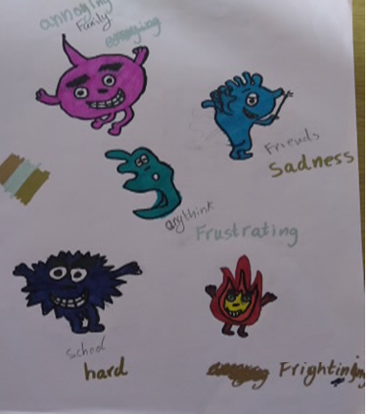

It may also mean that they appear fine one moment and the next they have an emotional or behaviour outburst, e.g. they suddenly become angry / aggressive / crying etc. with no apparent trigger.

They may also be displaying behaviours that would seem more appropriate for a much younger child, e.g. a 10 year old throwing a tantrum like a 2 year old. They are simply trying to stay alive in a world that their brain is telling them is dangerous.

While they are stuck in survival mode they will find it very difficult to manage their emotions or behaviour, concentrate, think, explain things in words or learn because the part of the brain responsible for these functions is not working properly because of the trauma.

**Many parents/carers feel that it is best to just ‘move on’ from the abuse, this is very unlikely to be best for your child or you in the long run as by doing this they are likely to remain in survival mode.**

**However, with the right help and support, children can cope with and recover from the trauma of sexual abuse.**

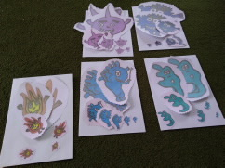

**The Science Behind Survival Mode: Friend, Fight, Flight, Freeze, Flop**

This next section explains the science behind why your child / children are reacting and behaving in the way they are.

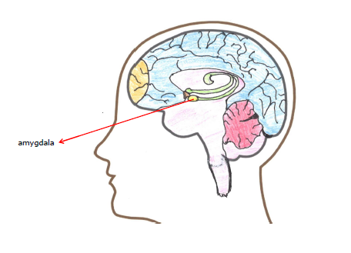

Friend, fight, flight, freeze and flop is known as the **TOXIC STRESS RESPONSE**. It is natural and normal and happens in all humans, adults and children. It is a **survival mechanism** controlled by a part of the brain called the amygdala.

The amygdala is working all the time and asking two basic questions:

* Am I safe?
* Am I important?

If it gets the answer ‘no’ to either of these the amygdala is activated and is given priority over all other brain functioning. When it gets the answer ‘no’ this may be a real threat or a perceived one. A perceived threat is where normal everyday sights, sounds, smells and events can trigger it when there is no real danger there, as described above.

When the amygdala is activated it causes the release of two chemicals:

* Adrenaline
* Cortisol

These then flow through the body causing biological changes within it. This release of chemicals is sometimes known as FLOODING.

These chemicals prepare the body to try to keep itself safe by going into one of the following survival strategies:

* Friend: attempting to make a connection with the person or scaring them to try to stop that person from hurting them , e.g. smiling, laughing
* Fight: anger, aggression, shouting, kicking, screaming, punching
* Flight: running away, wanting to leave, hiding, making yourself small, losing eye contact,
* Freeze: can’t move, stillness, can’t think, stuck or
* Flop: body goes all floppy, like an animal playing dead.

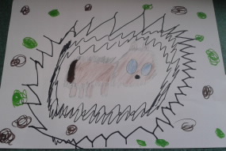

We generally have one of the above which is more dominant than the others. The survival strategy chosen will depend upon a number of things such as:

* What is least likely to result in death or injury?
* What has worked well before?
* What has not worked well before?

Adrenaline causes:

* muscles to be provided with more oxygen,
* heart to pump faster,
* the body's ability to feel pain to decrease,
* a noticeable increase in strength and performance.

Cortisol has many functions in the body some positive and some not so positive. When triggered during a stress response it:

* increases blood pressure which can cause headaches
* inhibits the immune system which means people may get poorly more often
* increases acid production in the digestive system possibly causing tummy aches
* shuts down the memory and thinking parts of the brain making it harder to make decisions, problem solve, think clearly and remember.

When the amygdala starts working, other parts of the brain are also altered which can affect a person’s body temperature, their appetite and their digestive system causing diarrhoea or constipation.

This is so that the body can focus its energy on friend, fight, flight, freeze or flop.

**The Tip of the Iceberg**

The behaviour your child displays is being driven by their underlying feelings, thoughts and emotions and by the fact that they are in survival mode. Their behaviour is just their way of telling you that they are, e.g. hurting, scared and/or anxious inside. For example when a child appears to be angry they may actually be feeling scared.

Like an iceberg you can’t always see what lies underneath



**This is what we see**

**Beneath the surface**

**Behaviour**

**Feelings**

**Emotions**

**Thoughts**

**\* Your Child’s Relationship with the Abuser \***

**Secrets and Lies**

Child sexual abuse cannot take place without secrecy. Abusers know it is wrong and often go to great lengths to stop the children they are abusing from telling someone.

Abusers often do not use physical force, but may use play, deception, threats; or other forms of coercion, e.g. telling them it is their own ‘special secret’; saying it is their way of showing they love them; making them think it is natural and ok or making them think no one would believe them; to engage children and maintain their silence.

Abusers know that talking about sexual abuse is a taboo subject which encourages their abusive behaviour. The secrecy and lies will affect how long it may take a child to disclose sexual abuse and how they then subsequently behave.

**Parental Support – Looking After Yourself: Page 36**

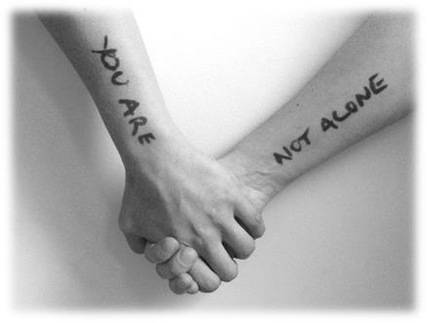

**Responding to the person who abused them**

How children and young people respond to the person who abused them will vary greatly. Some may want nothing to do with that person while others may still want to see them. This may change as they get older.

A child / young person’s decision about their relationship with the abuser may vary depending upon:

* the age of the child,
* the age of the abuser
* their relationship with the abuser (parent, cousin, family friend, sibling)
* the type of abuse that occurred
* the method the abuser used to stop the child / young person from telling
* how the child experienced the abuse at the time
* the way the abuse was discovered
* the circumstances of the disclosure
* other people’s reactions to the abuse and
* The impact of criminal proceedings

They may also feel very mixed emotions and confusion, particularly if their abuser was a close relative, e.g. I love them but they hurt me. I’m scared of them but I miss them.

You can support them with these mixed emotions by saying something like:

‘You can still love someone but hate what they did to you.’

‘You can like them but not what they did to you.’

Different siblings may also have very different views of the abuser which can be very challenging.

**Practical Tips to Help your Child**

The following tips may help you. These will need to be adapted to the age and level of understanding of your child / children.

**Remember: you know your child/children best, you are the expert; use your own instincts.**

* **Listen to them** (it can come out at any time so stop what you are doing and pay attention). Allow them to talk about the pain and grief. Acknowledge how they are feeling (It’s okay to feel …..).
* **Talk about it** with them when they are ready, either verbally or via drawings, paintings. They may act out to get your attention if they feel unheard or confused.
* As children grow their ability to understand and think about what happened to them changes so as they get older they will continue to need time to talk and ask questions. Perhaps **check in with them** every so often, every 6 months or so and possibly on the anniversary of the date of disclosure.
* If you can, take some time on a regular basis to have **1:1 time** with them, e.g. playing, reading, making something, cooking - whatever they enjoy doing. This creates a much needed safe, emotional connection for them. Doing this need only be for short periods of time.
* **Be patient!** If they do not want to talk don’t push them.
* **Be kind!** Respond with kindness if at all possible rather than with negative emotions.
* **Acknowledge** that it may be difficult or scary for them to talk to you about what happened and how they feel. This is important because once they start talking about it, it becomes less scary for them.
* If you cannot talk to your child / children or they won’t talk to you, try to find another **safe adult they trust**, e.g. teacher, another family member.
* Set firm, consistent and realistic **boundaries** - this will help them feel safe and secure so they do not need to operate in survival mode all the time.
* Give your child **affirmations** even if their behaviour is challenging, ‘I’m glad you are here.’ ‘I like who you are.’ This is to remind them that you love them no matter what.
* **Play** with your child/children as often as you can. It has been scientifically proven that play helps to calm children. If your child is older, try to spend time with them doing something they enjoy.
* Find ways for them to **relax**, if possible on a daily basis, e.g. listen to music, having a bath, having a bedtime story. Relaxation also helps to calm the body.
* If they have a flashback or panic attack help them to **focus on the present** – what they can see, hear, feel and smell. Encourage them to take slow deep breaths with the out breath being longer than the in breath.
* **Family memory jar**, on slips of paper draw or write about a positive family moment and store this in a jar. Objects that do not rot can also be put in, e.g. shell / pebble. On 31st December empty the jar out and look back over the year. Start the jar again on 1st January. The time scale can be shortened, e.g. weekly, monthly, depending upon the age of your child/children and circumstances.

**Remember: a year in a three year olds life is a third of their life, whereas a year to a 20 year old is only a 20th of theirs.**

**Give your children outlets for their feelings, ideas to do this:**

**Throwaway bag:** A bag can be drawn, made or used that you place negative feelings, thoughts, words or drawings inside. The bag is then thrown away or kept depending upon the child.

**Using their imaginative play:** Be a part of it, join in and allow them to express their feelings via mediums such as play dough, paint, sand, water, model toys - even if their play is aggressive. Allowing them to play gives them a safe outlet for their emotions.

**Calm zone:** Create a special, safe place at home with your child/children that they can go to when they start to feel emotionally upset. Put calming items in this space, e.g. books, teddies, blankets they can wrap themselves up in, something that has a favourite smell, an object(s) from the family memory jar etc. This is not to be used as a punishment space. Pop up tents are good for this.

**Paper and pens:** Allow your child/children to have access to crayons and paper or colouring sheets so they can draw or write or colour. Perhaps they could make a happy book.

**Music:** Listen to music. Dance to some loud music or relax to some calming music.

**Bad dreams:** Allow them access to paper and pens/crayons in their room so they can draw their bad dream. They may want to show it to you and talk about it, afterwards screw the drawing up and throw it away. Drawings of good dreams can be kept.

**Playdough / Slime Putty:** Squeeze it hard until it squidges through their fingers or press it really hard onto a plate to make pancakes – screw it up and make some more. This can be done with pizza dough or bread dough too.

**Swing Ball / Trampoline / Star jumps / Kicking a ball / Running / Swimming:** physical exercise is very good at calming the system down as well as releasing aggressive energy

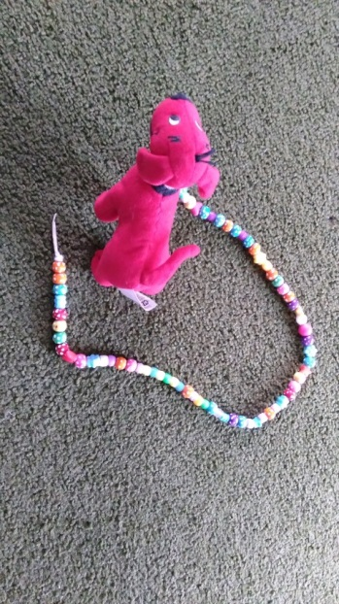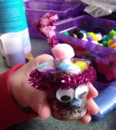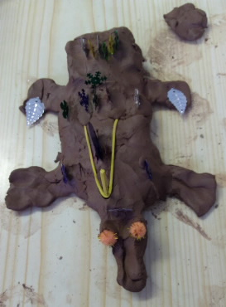

**Other things to remember**

1. Keep adult issues to adults; if you need to talk about the abuse and how you are managing and feeling find another adult who can support you. Your child does not need to take on your feelings of distress about the abuse, find help for yourself: see Parental Support – Looking After Yourself
2. Tell your child you love them.
3. Trust your instincts about what your child needs, whether they need to talk or have space.
4. Take time to calm your own emotions before responding to a situation with your child/children. Take a deep breath and think about what you are going to do and say before you react. Look after yourself because if you are stressed that you will not be in the right place to really support your child.
5. You are human! You can’t always be patient, kind or calm and sometimes you will get frustrated, angry or upset and may end up shouting. If you do, it’s okay and important to say sorry to your child/children. In fact saying sorry is vital as children not only learn that making mistakes is ok but they also learn how to repair a situation that has gone wrong.
6. When you are feeling angry, upset or sad because of the abuse reassure your child that they didn’t cause this, e.g. ‘I’m sad. You may see me cry. That’s all right. I will be able to take care of you. I’m not cross with you.’ ‘I’m not angry at you, I’m angry at the person who did this.’
7. Try to keep your lives as normal as possible: maintain your normal routines and family rules.
8. Keep your expectations realistic. Remember that your child will be affected by the abuse, and they may behave in a way that helps them cope with the confusion and mixed feelings they have. Try and put yourself in their shoes and think about what it is they are trying to say by behaving in the way they are. In this way you can show empathy. Empathy is when someone is able to share or understand the emotions and feelings of another person.

1. If the abuser was a male member of your household and he is no longer living with you, many boys may want to take care of his Mum and to take on the role of ‘the man of the house,’ don’t let them – they need to remain a child and not take on adult responsibilities.
2. Each transition or change in a child’s life can cause stress, e.g. move of schools, new home, change in parental partner, family separation, bereavement. These transitions may cause symptoms of the abuse to surface again – this is normal.

**You are the most important person for your child and you can all heal together.**



**Supporting Your Child**

The most important message you can give your child is that you do not blame them and that you do believe them. This is the foundation on which a child can start to believe what happened was not their fault and they can express their feelings and start to come to terms with them. This is the beginning of a pathway to recovery.

Below are some helpful Do’s and Don’ts to follow:

DO:

* Give them time to talk to you at their pace
* Listen to them
* Allow your child to talk about the confused way that they may feel
* Give them choices and explore their options with them
* Offer unconditional support
* Explain to your child in words they can understand what is happening with any court or legal action which may be taking place
* Remain calm when talking with your child or managing their emotions / behaviours. At times this is much easier said than done but by staying calm you will help your child calm quicker and will not escalate things further
* Try to understand as much as you can about the effects of child sexual abuse so that you can best support yourself and your child
* Ask for help for yourself

Who do you think needs to know now, who at school shall we talk to, which of your friends shall we share this with (7 years upwards)

Try not to worry about me we need to look after you

I am going to help you; we will get through this together

I will do all you can to keep you safe

We need to remember there may be some people we have to talk to like our social worker and the police because they are going try to keep you safe

It’s ok to feel ….. angry / confused / worried

I believe you

I love you and I am really glad you told someone

It wasn’t your fault…what they did to you was wrong, and it wasn’t ok

TRY TO AVOID:

* Getting upset every time your child talks about the abuse
* Make promises about what will happen to the person who abused them or promise that they will never have to see them again. These may be promises you can’t keep. Your child needs to trust you so it is better to say you don’t know.
* Stop your child’s play or other activities any more than you must for your own piece of mind – play and having fun is healing

**I wish you hadn’t said anything…because…**

**It was all my fault**

**It is your fault**

**I don’t want you talking to anyone about this**

**Let’s forget it happened, put it behind us and move on**

**I promise you won’t have to see them again**

**How does sexual abuse affect a parent/carer?**

Not only is a child affected by abuse they experienced but so is their parent(s)/carer(s). Parents/carers are secondary survivors. Post-disclosure (after your child has told someone about the abuse (telling)) can be a chaotic, painful and overwhelming time. As a parent / carer you may find that you go through many different emotions yourself such as:

* grief / pain
* feeling of loss
* sadness
* shock
* anger / rage
* desire for revenge
* denial
* guilt / self-blame
* confused
* overwhelmed
* numbness
* relief

Worry / anxiety including about the effect the abuse has had on your child, how to tell other people, how others will react

Feeling out of control and mood swings

Feeling you have failed as a parent and a possible loss of confidence in parenting abilities

Isolation and loneliness, especially if certain people believe the abuser instead of your child and you

* shame
* betrayal
* disgust
* stress
* anxiety

You may also:

Feel helpless

Have negative thoughts, ‘I should have known.’ ‘It’s my fault.’ ‘I can’t do this.’

* feel that you are a bad parent
* believe that you are to blame for the abuse
* think you have lost touch with your child/children
* lack confidence to re-establish boundaries or healthy relationships with your children
* have trouble sleeping
* get headaches
* be exhausted - physically and mentally

These are **natural** and **normal** responses; you too have gone into **survival** mode because you are a **secondary survivor**.

Attempting to parent a traumatised child when you are in trauma yourself can be frightening, challenging and very tiring.

**One of the most important ways to help your child heal and recover is to look after yourself.**

**This is not being selfish, it is vital. This is so that you have the emotional capacity to support your child.**

**[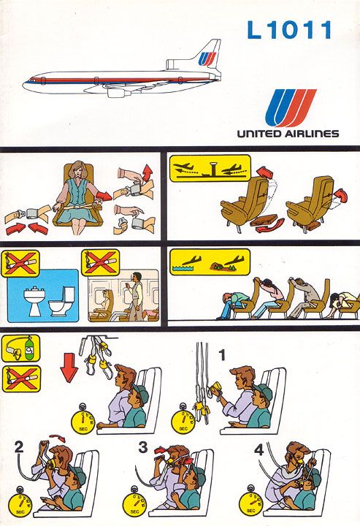](https://www.pinterest.co.uk/pin/299911656404847852/)**

**Remember: you need to look after yourself, for example ‘if’ you were in an aeroplane you are told to put your own oxygen mask on first, before helping others as you are not able to support anyone else if you can’t ‘breathe.’**

**When you are feeling better about yourself and your wellbeing is OK or good, it is much easier to be a consistent parent and to be able to support your child more effectively.**

**Effects on Family and Friends**

Family and friends may display a variety of different reactions to the news that a child of yours has been abused including:

* anger/ shame
* fear: ‘I don’t want my children to hear about this.’ ‘What if X talks about it to my children?’ ‘How will people react’
* grief / loss / pain
* shock / denial
* blaming you / your child
* confusion/ frustration
* bewilderment / embarrassment
* minimisation of the abuse
* wanting to forget it
* not wanting to talk about it so that it ‘goes away’
* making accusations / blaming
* making negative comments: ‘poor child.’ ‘how could you not have known about the abuse?’ ‘he/she probably just made it up.’ ‘he/she will get over it, kids are resilient.’

Their response may lead to changes in communication and relationships; and potentially cause family ruptures and/or breakdowns in relationship. Some examples could include:

* Family celebrations and holidays change as certain parts of the family no longer get together.
* Family dynamics may change due to mistrust or the child’s reaction to certain members of the family.
* Extra care is taken that children are not left alone with other family members.
* Bathrooms and bedrooms are watched.
* If the perpetrator lives close by a move may be necessary.
* Loss of friendships

**Hagans and Case (1988) provide helpful hints for responding to others about your child's abuse:**

Protect your child's privacy as much as possible. They are experiencing a range of emotions as a result of the abuse and may be embarrassed that others know. You do not have to provide details about the abuse to anyone, except people like police, school, support services.

Discuss with your child the people who are told about the abuse. The victim, depending on age, has a right to know who knows. Ask family members not to discuss the abuse with others. Again, the goal is to protect your child and their privacy.

Preparing ahead of time with responses will help you feel less anxious. Help your child develop and practice responses to questions about the abuse. Let them know that they do not have to respond to comments. Teach responses like: "I'd rather not talk about it," "thank you for your concern", "My mum told me not to talk about it now."

Be aware that young children may bring the abuse into a conversation at unpredictable times. Be prepared. You may talk to your child and provide guidelines for who is safe and unsafe to talk to about the abuse.

It is okay to be firm, abrupt ….with people that are intrusive with their questions.

You can say that you do not want to talk about it; you appreciate their concern and change the subject.

You can just nod your head and say nothing.

You do not have to agree or disagree with conversations.

(Extract taken from: <http://www.mosac.net/page/299>)

Sexual abuse can also put a great deal of strain on the relationship between couples. This may be because they react in different ways and their coping strategies may be different. It is very helpful if each partner can try to recognise and acknowledge that their partner may have a totally different way of managing. It doesn’t mean one way is better than the other, they are just different.

**Intra-Familial Sexual Abuse**

In this form of abuse, a family member is the perpetrator of the abuse. The family member may not be a blood or step / half relative, but could be someone who is considered ‘part of the family’, such as a godparent or very close friend.

This form of sexual abuse can put a tremendous strain on family relationships. Some members may find it hard to believe the person could perpetrate abuse; others may take sides while others may struggle to manage their divided loyalties towards the abuser and the survivor. It could also result in family separations leading to feelings of self-blame and guilt by yourself and your child.

**All of the above is another reason why it is important for you to look after yourself.**

“I honestly have no way to ever thank you enough for keeping us going and on the right track; and also for making me feel less like and awful parent ☺”

**Parental Support – Looking after Yourself**

**Here are some tips on how to care for you:**

1. Try to stop being so hard on yourself: it’s ok to feel …… angry, sad, guilty
2. Try not to scare yourself with negative thoughts. Find a mental image that makes you smile and feel happy. Think of this when you start having negative thoughts.
3. Be gentle, kind and patient with yourself.
4. If your child is saying things such as, ‘I hate you.’ Try not to take it personally; they are unlikely to be true it is just your child’s way of expressing the strong emotions they have inside at that time.
5. Give yourself time to heal. Don’t expect too much too soon and allow yourself to recover at your own pace. You need time to experience and process what has happened, to mourn and feel the grief, to cry to rage.
6. Time for a cup of tea! After your child has had a meltdown you may be feeling very tired and drained, once they are calm again take a short break. Even a few deep breaths will help if a break is not possible or plan something for once they are asleep, e.g. a bath.
7. Unfortunately certain type of crises, like child sexual abuse, does not always bring positive responses from friends and family. Work out who in your network of family, friends and acquaintances is able to provide you with emotional support. Don’t wait until you are at the end of your tether to ask for help. Also ask for what you need, tell them what you need from them as they are unlikely to know, e.g. babysitting, someone to listen to you, come over and have coffee, take your child to school.
8. Be kind to your mind - don’t hate yourself for having negative thoughts, acknowledge that you have them and then try to move on from them. Writing them down and then throwing the piece of paper away may help.
9. Praise yourself - tell yourself how well you are doing. Start by paying attention to small events and details that have had a positive impact on you.
10. Set aside time to do things that you enjoy, even if it is only for a few minutes each day: reading, having a bath, seeing friends, going for a walk, cooking, exercising.
11. Maintain your normal daily / weekly routines.
12. Take time to relax – try to do this daily even if it is only for a few minutes.
13. Start a positives book - write down positive changes that you notice in yourself and your child/children. During tough times look back through this book to reflect on how far you have already come.
14. Find support for yourself - from friends and family. Speak to your GP, possibly discuss a referral to Talking Therapies or other counselling services, see: Other Useful Contacts.
15. Take care of your body - e.g. nutrition and sleep. When you are well nourished and have enough sleep you will be physically and mentally better able to parent.

Find time for you as an adult, you are not just a parent.

Treat yourself from time to time.

“I wish that the Somerset Phoenix Project could be doing work with all children through all their trials and tribulations. What a difference it would make!”

“I would like to say that I have found the Phoenix project a wonderful help to our children, the progress they have made is brilliant! They talk to me about anything that is worrying them (which they did not do as much before our phoenix worker). Yes the day to day stuff is hard but to know that they will open up to me is a great relief! I can think of a lot more but it is hard to explain how much you have helped us! As it’s the little things that have improved which over all helps the big picture in the long run. Thank you for all your help”

**Nurturing your child**

Here is a useful summary of practical ways you can care for and nurture your child.

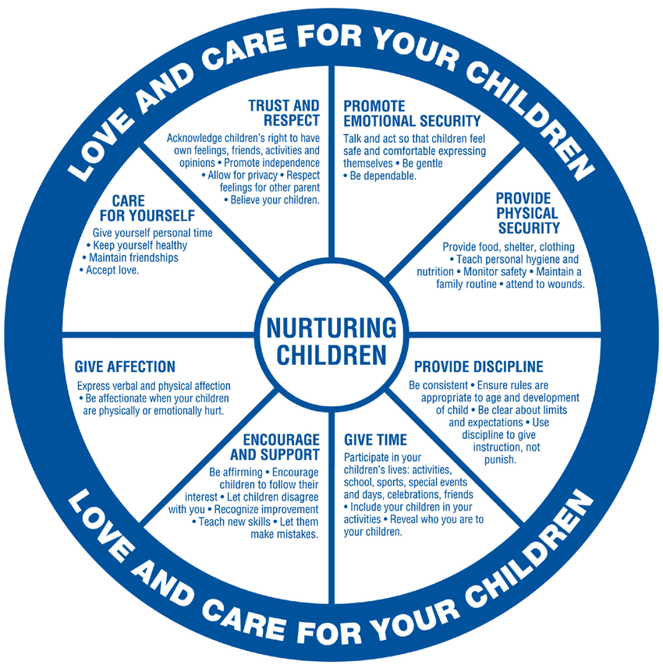

Source: Domestic Abuse Intervention Project, 202 East Superior Street, Duluth, Minnesota. Adapted by Texas Council on Family Violence.

**\*Useful Video Clips\***

***Please note***: the Phoenix Team cannon accept any responsibility for the content of You Tube clips.

Below is a list of You Tube clips that you may find helpful either for yourself or the families and children you are supporting. Just type the title(s) below into the You Tube search engine and it should find them for you. An image of the first screen you see has been added below to help you check you have got the right clip.

Some of these clips may be distressing to watch, these have been marked with a \*

\*10 Reasons Children Don’t Disclose Abuse\*



Hope and Healing Lauren’s Kids

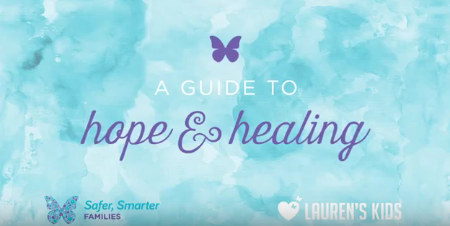

Brene Brown on Empathy



Dan Siegel Name It To Tame It



Dan Siegel – “Flipping Your Lid:” – A Scientific Explanation



Focus on the section from 0:00 – 01:58 especially

Taming And Tending Your Meerkat Brain | Jane Evans | TEDxBristol

This is a long clip, if you do not feel you have the time to watch it all focus on the section from 08:13 – 16:07



**Clips for Your Children and Parents/Carers**

Before showing any of these to your child(ren) please make sure you have watched them first so you can decide whether it is appropriate to share with your child(ren).

Take 5 Breathing: A Calm Down Technique for Kids

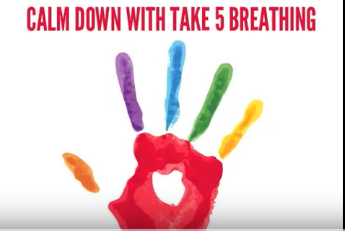

"Just Breathe" by Julie Bayer Salzman & Josh Salzman (Wavecrest Films)

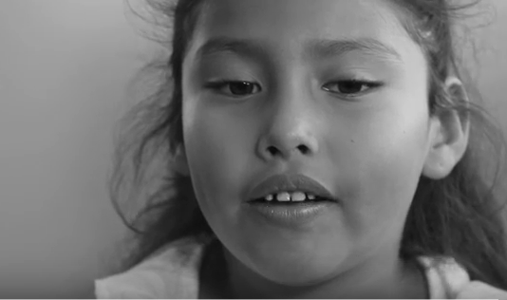

Kids Explain Mindfulness

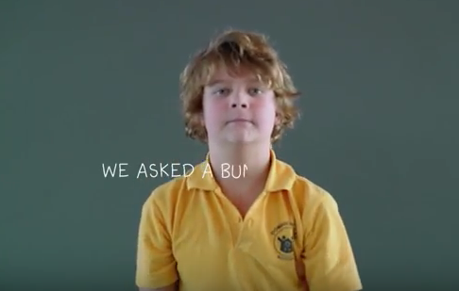

Calm Down and Release Your Amygdala



Your Fantastic Elastic Brain

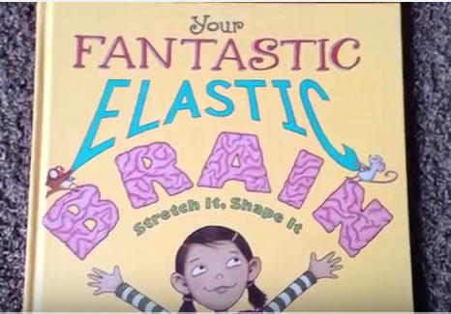

There are several versions of this on You Tube, e.g. Kristi Oster, find one that suits you / your child best.

A Secret Safe To Tell by Naomi Hunter

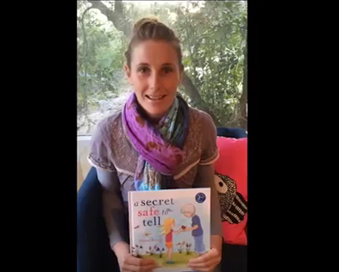

**The Court Process, Preparing for Court, Giving Evidence and Post Trial**

Evidence

After a disclosure has been made and it has been reported to the police, the police will gather evidence. One piece of evidence they gather is from the child/young person via an Achieving Best Evidence (ABE) interview. These are videotaped.

A trained intermediary may be used to help the child/young person communicate with the police. They will meet the child/young person and their family before the ABE is undertaken. They can also support the child/young person through the court process if the case goes to trial.

The Role of the CPS

The decision to charge is made by the Crown Prosecution Service (CPS). When making a decision to charge, the CPS will look at the available evidence and ask:

1. Is there enough evidence for a realistic conviction?
2. Is it in the public interest to prosecute?

This is referred to as the two stage test.

The views of the child/young person can be taken into account but ultimately it is the decision of the CPS. A child/young person may withdraw their complaint by making a statement. The CPS may still continue with the prosecution without the victim’s evidence or they may summon them to court. This would be done under number 2 above – public interest.

If a decision is made not to prosecute (not to go to trial), the victim has the right to appeal against the decision under the Victim’s Right to Review scheme (VRR). The decision not to prosecute is communicated in writing.

From the CPS’ decision to go to trial to the actual trial occurring can be up to a year. During this time, the defendant (the person being accused of the crime) can be kept on remand (in prison) or be out on bail. There are likely to be bail conditions, e.g. no contact with XX. They may also be tagged. A ‘Treat As Urgent’ (TAU) marker may be placed on their victim’s property address. If they breach their bail conditions they will be arrested and reminded of the conditions.

Which Court

All criminal cases start at the Magistrates Court, with more serious crimes such as sexual violence, being transferred to Crown Court. Local Crown Courts are Taunton, Bristol, Bath and Exeter.

When the defendant is a young person, he / she may be tried in a Youth Court. A Youth Court is part of the Magistrate Court. In the Youth Court no public are allowed to attend and there is no jury. The case is heard by a District Judge or 3 Magistrates. The Youth Court does not have the same sentencing powers as the Crown Court. Often the young person may choose to go to Crown Court for a full trial because there is a jury.

Preparing for Trial

It may take 6 – 12 months between making the decision to prosecute and the trial.

During this time the Prosecution (arguing for the victim) and Defence (arguing that the accused is innocent) will meet to prepare the case. There may be other court hearings, e.g. the defendant will have to enter his / her plea, to arrange issues like special measures (see separate section) or for the Judge to give direction on things that need to be done before the trial.

The child/young person DOES NOT need to be present at any of these hearings but updates should be provided by the ‘Victim and Witness Care Officer’ (see explanation below). If the person is under 18 years of age all communication is sent to their parents / carers.

Everyone has the right to a fair trial therefore the CPS has to show all evidence to the defence so they can prepare their case.

Victim and Witness Care Officer

They work for the police but they do not investigate the crime. They are responsible for ensuring the victim or their parents/carers if the victim is under 18 years of age is given court updates and is offered the relevant referrals to specialist agencies for the person’s wellbeing as a victim of crime.

What are Special Measures?

There are practical arrangements that are made to assist the child/young person to give their best evidence in court. All victims of sexual violence should request special measures; this can be done by the police on their behalf.

Special Measures can include:

* A screen around the witness box
* Giving evidence via a live link (with this option the victim can only see the person speaking to them, e.g. barristers / judge, but the whole court room can see them)
* Removal of wigs and gowns
* Video evidence
* Examination of a witness through an intermediary – this is someone appointed by the court to assist a witness because they have a disability that effects their ability to communicate or they are a young witness
* Examination using communication aids
* Make provision for the presence of a supporter to the witness in the live link room – this cannot be a member of their family but has to be someone independent, e.g. Independent Sexual Violence Advisor (ISVA) / Intermediary

Note of Caution: It is not unknown, however, for special measures to be agreed, e.g. screen in court, and for the witness to turn up and find that these have been overturned as the defendant’s barrister has fought to get them removed.

Before Giving Evidence

Memory Refresh:

Because it may have been several months or up to a year since the victim was interviewed by the police, the week before or even the day before the trial, a victim will be given the opportunity to watch their video / ABE interview and read any written statements they may have made.

Sometimes an ISVA / Intermediary can be present sometimes not – there are no clear guidelines on this.

Pre-Trial Visits:

The ISVA or Lighthouse can liaise with the Witness Care Service (see below) so a visit can be organised before the trial to have a look around the court and witness waiting areas.

The ISVA can accompany the victim. Family and other support can also attend.

Witness Care Service:

The witness care service is part of the Citizens Advice Bureau. They are based in court and can assist with pre-trial visits to view the court building and court room. They can also be in the court room during the trial to support the victim. They do not know the details of the case.

Defendant:

The defendant can change his / her plea at any time before or during the trial. They may choose to enter a guilty plea, more than likely to any lesser offences. If this happens the CPS and Police will consult with the victim to decide what happens next, e.g. accept the plea or continue to trial.

The Trial

The victim will meet the prosecution barrister before the trial commences. There will also be an opportunity to meet the defence barrister and the judge if the request is made.

The Jury will be sworn in.

Opening speeches are given by the prosecution. This is the first time the jury get to find out what the case is about.

The video / ABE interview will be played to the court room. This is the evidence-in-chief. If a written statement was provided, the prosecution barrister will talk through it.

The Judge will tend to be the first person to speak to the victim giving evidence.

Following the judge, the defence barrister will cross examine the victim / witness.

The victim / witness is re-examined by the prosecution.

Possible questions from others, e.g. judge / jury could then be asked.

If the child/young person is giving evidence in a separate room their parent / carer is not allowed to be in there with them. The ISVA / Intermediary is sometimes allowed in.

After this the victim / witness is allowed to leave.

The trial will then continue with the prosecution presenting their case and then the defence presenting their side of the case. The defence barrister will sum up the case last and then the judge will give the jury some direction about the law to assist them to make their decision.

After the Trial

In Magistrates court there is no jury so the District Judge or 3 Magistrates will decide if the defendant is guilty or not guilty. The Magistrates do not all need to agree.

In Crown Court the jury need to reach a verdict upon which they ALL agree. If a decision cannot be made upon which they all agree, they can be told by the judge that they can return with a majority verdict – this is not common.

Hung Jury - If the jury cannot decide on a verdict this is classed as a Hung Jury. In this case the defendant is neither convicted nor acquitted. If this happens the victim is given a couple of days to decide whether they wish to go for a re-trial. If they do, the process will start again with a new set of jurors.

Not Guilty – the prosecution will not be able to prove the defendant’s guilt to the very high standard required. The victim does not have the right to appeal.

Guilty – sentence may be passed immediately or the case may be adjourned to enable pre-sentence reports to be prepared. The victim and his / her family can be present for the sentencing. The ISVA / Intermediary can go with them. While the case is adjourned before sentencing the defendant can be out on court bail even though they have been found guilty. The defendant does have the right to appeal against the decision and there could be a re-trial as a result of the appeal.

Each offence in the Sexual offences Act carries and maximum and minimum sentence. It is the judge’s decision to sentence.

Victim Impact Statement (VIS) or Victim Personal Statement (VPS)

When there is a guilty verdict a VIS or VPS is an opportunity for the victim to write down how the crime has affected them. This will be taken into account by the judge when sentencing. The VIS / VPS can be read out by the victim in court or they can have someone else (e.g. judge / barrister) read it out for them.

A parent / carer can write this statement on behalf of a young child.

ISVA’s can support their clients to write these statements.

VIS / VPS’s can be taken more than once during the process, e.g. at disclosure and police interview; after re-watching their ABE interview and after the trial.

Any breaches of bail conditions will also be taken into consideration by the judge when considering sentencing.

Criminal Injuries Compensation

This is a government scheme to compensate victims of violent crime for their physical and mental injuries.

An application must be made as soon as possible. There is a 2 year limit BUT it is advisable to wait until there is an outcome, such as after court. Applications for compensation will be disclosed to the defence and can be used to undermine the victim’s account.

This can be done online at: <https://www.gov.uk/government/organisations/criminal-injuries-compensation-authority>

**Useful Links for Court Information**

**Rights of Women**

[www.rightsofwomen.org.uk](http://www.rightsofwomen.org.uk)

This provides legal guides and handbooks containing vital legal information to help women and children through the law. ‘From Report to Court’ and ‘Your rights, Your Body, Your Life: Sexual Violence and the Law: a YP’s Guide’ are both good documents.

**Victim Support**

[www.victimsupport.org.uk](http://www.victimsupport.org.uk)

This charity helps survivors of crime. The website includes a section on going to court before trial, during trial and after trial.

**You and Co**

[www.youandco.org.uk](http://www.youandco.org.uk)

This is Victim Support’s youth programme. It helps young people cope with the impact and effects of crime. It includes an online interactive court room.

**Government**

[www.gov.uk/going-to-court-victim-witness](http://www.gov.uk/going-to-court-victim-witness)

**Citizens Advice**

[www.citizensadvice.org.uk](http://www.citizensadvice.org.uk)

(The above information about court was provided courtesy of SafeLink.)

**Supporting Your Child / Young Person During a Police Investigation / Trial Process**

The advice often given to parents / carers is not to talk to their child about the evidence or what happened to them. However, parents are allowed to talk to their child about the court process: who’s who, the court building, facts about the court process, possible outcomes etc.

If your child does talk to you about what happened:

DO:

* Listen
* Be supportive
* Be empathic

DO NOT:

* Question them
* Lead them
* Ask for details

Listen very carefully to what they say and, when it is appropriate to do so, note down what they said to you, the FACTS only. If you are able, note down their exact words. Once you have done this contact the police officer responsible for the case to let them know what your child said to you.

**LISTEN – RECORD – LET THE POLICE KNOW**

**Useful Contacts**

***Please note***: the Phoenix Team cannon accept any responsibility for the content of external websites.

**LOCAL SUPPORT**

**SARSAS (Somerset & Avon Rape and Sexual Abuse Support)**

[SARSAS](http://www.sarsas.org.uk/) offer a Helpline service.

For numbers and operating times see above.

SARSAS have also developed a number of self-help [guides](http://www.sarsas.org.uk/child-abuse/) on sexual abuse. [**www.sarsas.org.uk**](http://www.sarsas.org.uk/)

**The Bridge**

[The Bridge](http://www.thebridgecanhelp.org.uk/) provides crisis intervention and support around collection of evidence that sexual abuse has occurred. They have a 24 hour phone line and a separate friends and family service.

SARC – also provide counselling for recent sexual assault for Men, Women and young people 14+

[**www.thebridgecanhelp.org.uk**](http://www.thebridgecanhelp.org.uk)

**0117 342 6999**

**Safelink**

[Safelink](http://www.safelinksupport.co.uk/) provides Independent Sexual Violence Advisors (ISVA). This includes advocacy support when reporting to the police and going to court.

**www.safelink*support.co.uk***

**0333 323 1543**

**Somerset Sexual Violence Services Pathway**

For more information about any sexual violence services in the South West:

[**www.survivorpathway.org.uk**](http://www.survivorpathway.org.uk)

**The Green House**

[The Green House Logo](https://the-green-house.org.uk/)The Greenhouse is a registered charity which provides free, confidential specialist counselling / therapy and support for men, women and children who have experienced or been affected by sexual trauma at any point in their lives. Although the counselling the Green House offers is mostly within Bristol there are useful resources including information leaflets on their website.

[**www.the-green-house.org.uk**](http://www.the-green-house.org.uk)

**0117 935 1707**

**Trauma Recovery Centre (TRC)**

[Trauma Recovery Centre](http://www.trc-uk.org/)The TRC facilitates recovery for children and young people as they process trauma as well as providing training for professionals.

[**http://www.trc-uk.org/**](http://www.trc-uk.org/)

**Email:** [**admin@trc-uk.org**](mailto:admin@trc-uk.org)

**Young Victims Service**

[](https://youngvictims.wordpress.com/)Young Victims Service is for young people from 8 to 18 (can be up to 25 for those with additional needs) who need help and support having been victims of crime and/or anti-social behaviour.

[**https://youngvictims.wordpress.com/**](https://youngvictims.wordpress.com/)

**01275 88 44 88**

**SIDAS**

This is the local domestic abuse support service.

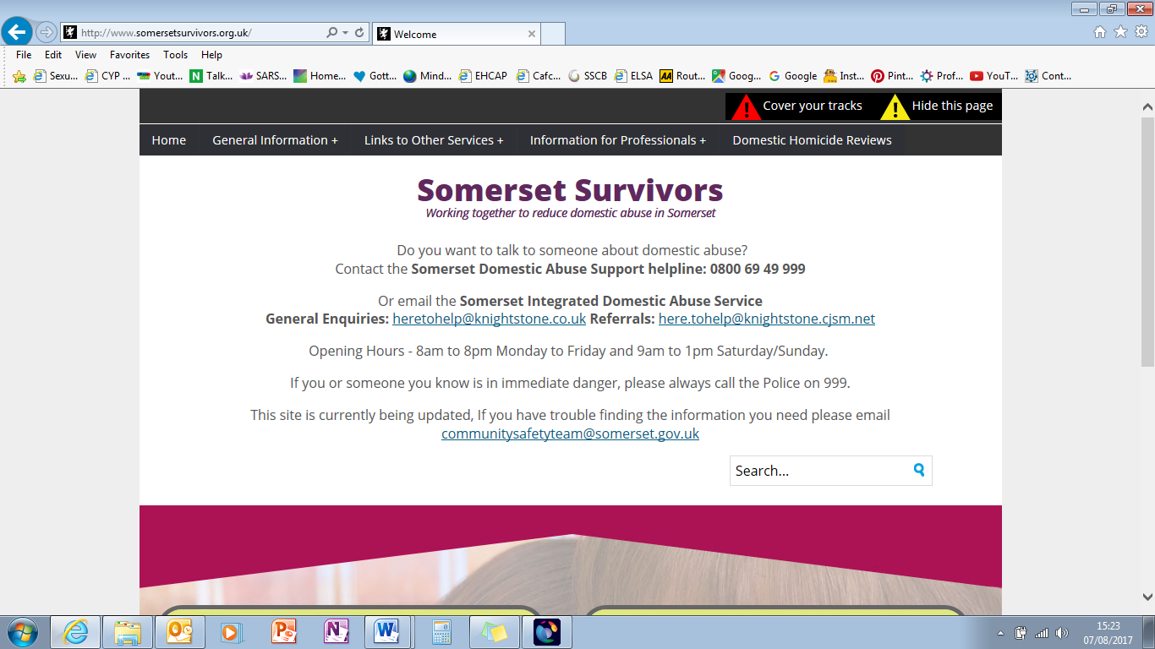[**http://www.somersetsurvivors.org.uk/somerset-integrated-domestic-abuse-service/**](http://www.somersetsurvivors.org.uk/somerset-integrated-domestic-abuse-service/)

**0800 69 49 999**

**NATIONAL SUPPORT**

**NSPCC**

[The NSPCC](http://www.nspcc.org.uk/) has some useful [resources](https://www.nspcc.org.uk/services-and-resources/services-for-children-and-families) designed to help support children affected by child sexual abuse. The NSPCC also provide helpful [definitions](https://www.nspcc.org.uk/preventing-abuse/child-abuse-and-neglect/child-sexual-abuse/) of sexual abuse.

**www.nspcc.org.uk**

[](https://rapecrisis.org.uk/index.php)

**Rape Crisis England and Wales**

Provides information about rape and sexual abuse.

[**https://rapecrisis.org.uk/**](https://rapecrisis.org.uk/)

**0808 802 9999**

**Mosac**

[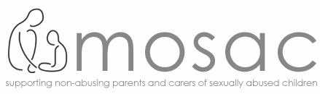](http://www.mosac.org.uk/)Mosac offer a national helpline for parents and carers of children who have been sexually abused.

[**http://www.mosac.org.uk/**](http://www.mosac.org.uk/)

[**http://www.mosac.net/**](http://www.mosac.net/) (this is the Australian version and has lots of very helpful information pages on it)

**0800 980 1958 freefone (or 020 8293 9990) weekdays**

**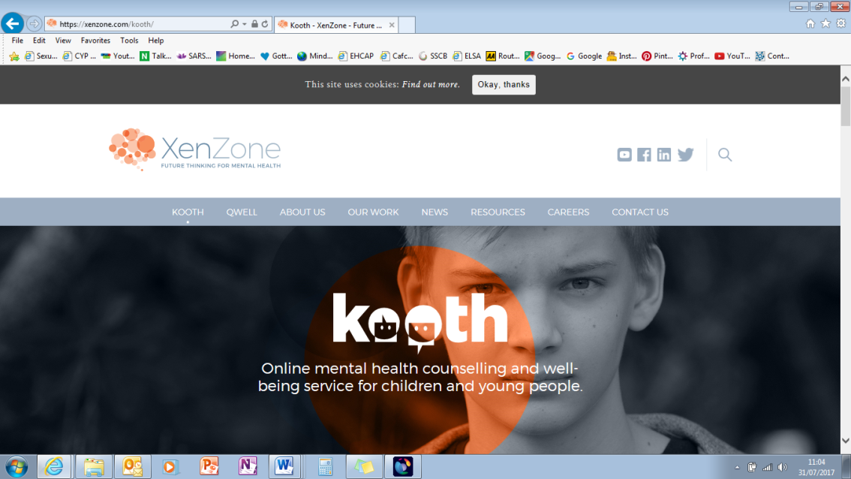Kooth**

**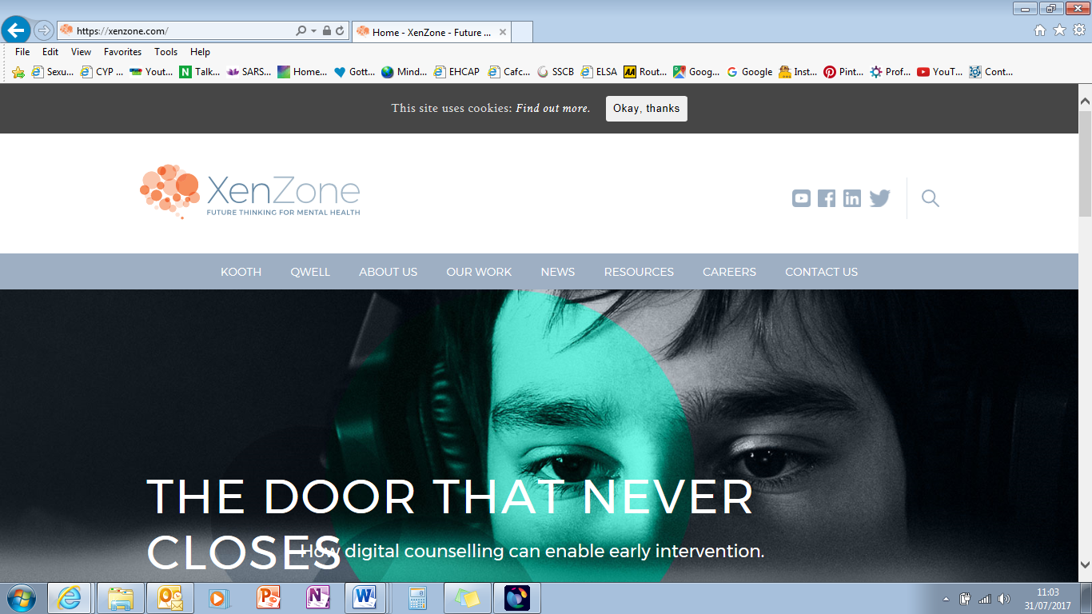Offers** free, safe and anonymous online support for young people.

**<https://xenzone.com/kooth/>****[https://kooth.com/](https://xenzone.com/kooth/)**

**0845 330 7090**

**Stop It Now**

**It is a child sexual abuse prevention campaign run by the Lucy Faithfull Foundation. They support adults to play their part in prevention through providing sound information, educating members of the public, training those who work with children and families and running their freephone confidential helpline.**

[**https://www.stopitnow.org.uk/**](https://www.stopitnow.org.uk/)

**0808 1000 900**

**GENERAL SUPPORT**

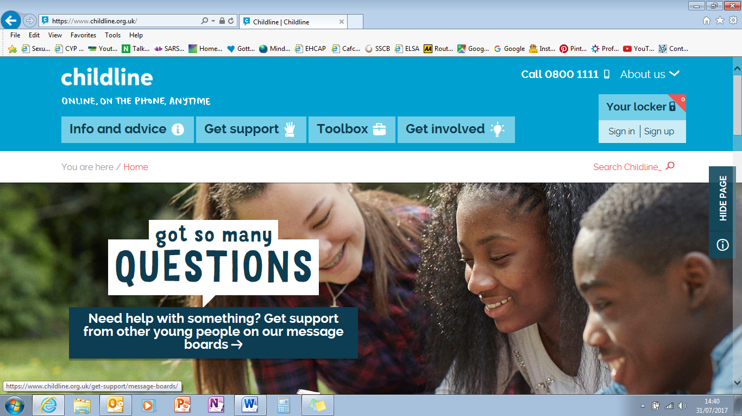**Childline**

This is a private and confidential service for children and young people up to the age of 19. They are able to contact a counsellor to talk about any issues.

[**https://www.childline.org.uk/**](https://www.childline.org.uk/)

**0800 1111**

[](https://www.victimsupport.org.uk/)

**Victim Support**

This is an independent charity supporting people who have been affected by a crime or traumatic event. They aim to help people feel safer and find the strength to move forward after a crime.

[**https://www.victimsupport.org.uk/**](https://www.victimsupport.org.uk/)

[](https://www.lighthousevictimcare.org/)**0300 303 1972**

**The Lighthouse**

A team of staff from the police and victim support organisations, who work together to guide, advise and support victims and witnesses of crime.

[**https://www.lighthousevictimcare.org/**](https://www.lighthousevictimcare.org/)

**101**

[Accessibility help](https://www.victimsupport.org.uk/accessibility-help)

**Young Minds**

UK’s leading charity committed to improving the emotional wellbeing and mental health of children and young people.

[**www.youngminds.org.uk**](http://www.youngminds.org.uk)

**0808 802 5544**

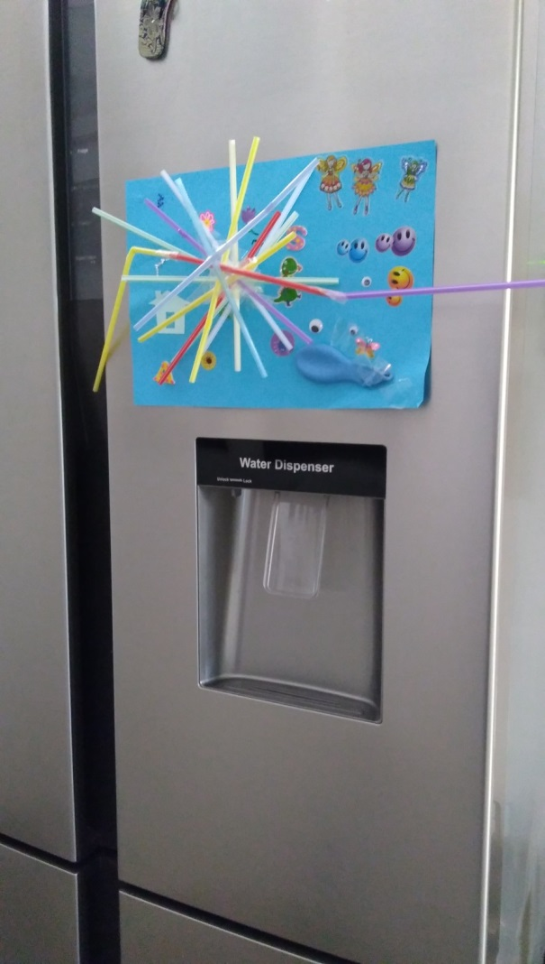

**Useful CSA Terms and Acronyms**

***Note:*** You will not find all the following terms and acronyms used or referenced in this guide but you may come across them in other CSA related documents.

**Achieving Best Evidence:**

This is the video recorded evidence taken by the police.

**Child Advocate:**

A Child Advocate is an independent person who can offer impartial advice and support to a child or young person. The main purpose of a child advocate is to enable children to express their wishes and feelings. A Child Advocate cannot represent a child during court proceedings although they may be called upon to give evidence at certain stages. They can, however, ensure that a child or young persons’ legal rights are upheld and that they are fairly treated.

**Child Protection Officer:**

These are officers who are part of the investigation team. They have an increased level of training and they would also act as the equivalent of the Family Liaison Officer throughout the investigation.

**Criminal Injuries Compensation Authority:**

This is a government scheme whereby victims of a violent crime are entitled to apply for compensation for the physical and mental injuries they have suffered as a result of the crime perpetrated against them. There is a 2 year limit to make an application. An application can be made online: [**https://www.gov.uk/government/organisations/criminal-injuries-compensation-authority**](https://www.gov.uk/government/organisations/criminal-injuries-compensation-authority)

**Digital Penetration:**

This is penetration where the fingersof the perpetrator are forced/inserted into the vagina or anus of the victim.

**Crown Prosecution Service (CPS):**

Once the police have completed their investigation the CPS will review all the evidence and will then make a charging decision. The CPS has specially trained Rape and Serious Sexual Offence (RASSO) lawyers who will assess whether there is a realistic chance of prosecution.

**Dissociation:**

This is often described as zoning out or mental flight – body and mind separate. Dissociation is a way in which some children survive abuse by escaping mentally to a place of safety while the abuse is happening. Different children may dissociate in different ways.

**Flashbacks:** These are a sudden, powerful, re-experiencing of a past experience or elements of a past experience.

**Independent Sexual Violence Advisor (ISVA):**

These are professionals trained to provide emotional and practical support to survivors of rape, sexual abuse and sexual assault who have reported to the police or are considering reporting to the police. They provide support from the moment of reporting to the police though to the court stages. **Locally these are provided by Safelink – see contacts section.**

**Intra-Familial Sexual Abuse:**

This means sexual abuse that occurs within the family. In this form of abuse, a family member involves a child in (or exposes a child to) sexual behaviours or activities. The “family member” may not be a blood relative, but could be someone who is considered “part of the family,” such as a godparent or very close friend.

**Officer in Charge (OIC):** This is the police officer responsible for investigating the case.

**Sexual Assault Referral Centre (SARC):**

This is a special facility where survivors of rape or sexual assault can receive immediate help and support. They offer STD and pregnancy tests and forensic medical examinations from trained staff. They also provide crisis workers who can support the survivor. **Our local one is The Bridge – see contacts section.**

**Sexual Offences Prevention Order:**

Sexual Offences Prevention Orders (SOPOs) are a type of civil order. A SOPO can prohibit the defendant from doing anything outlined in the order. This is what is considered ‘necessary to protect the public from serious sexual harm by the defendant.’ They can be imposed either at the time of conviction or post-conviction if an application for such an order is made.

**Sexual Violence Multi Agency Risk Assessment Conference:**

This meets each month and is attended by representatives from a range of statutory and voluntary agencies. Each meeting looks at 6 victims, all who have complex needs. They work together to draw up a multi-agency action plan to prevent re-victimisation.

**Victim Contact Scheme:** The statutory Probation Service Victim Contact Scheme (VCS) is offered to victims of violent sexual offences where the offender receives a sentence of 12 months or more. If the victim chooses to take part they are entitled to things such as being assigned an officer who will act as their point of contact and deciding whether they wish to receive information about key stages of the offender’s sentence.

**Witness Care Unit (Lighthouse):** These are part of the police, they do not investigate the crime but are responsible for ensuring that the survivor / the survivor’s family have court updates and are offered relevant referrals to specialist agencies for their wellbeing a s a victim of crime.

**Witness Service:** The witness service are based in court and are part of the Citizens Advice Bureau (CAB). They will assist with pre-trial visits to court and also in court on the day they witness / survivor gives evidence. They do not know details of the case.

**Acronyms**

ABE – Achieving Best Evidence

CICA – Criminal Injuries Compensation Authority

CPO – Child Protection Officer

CPS – Crown Prosecution Service

CSA – Child Sexual Abuse

CSE – Child Sexual Exploitation

ISVA – Independent Sexual Violence Advisor

OIC – Officer in Charge

SARC – Sexual Assault Referral Centre

SIDAS – Somerset Integrated Domestic Abuse Service

SOPO – Sexual Offences Prevention Order

STO – Specially Trained Officer

SV MARAC – Sexual Violence Multi Agency Risk Assessment Conference

VRI – Video Recorded Interview



And just as the Phoenix,

Rose from the ashes,

She too will rise.

Returning from the flames,

Clothed in nothing but her strength,

More beautiful than ever before.

Shannen Heartzs



**Phoenix Contact Information**

**You can phone or text the Somerset Phoenix Team to request support.**

Telephone

**07590 627693**

This line is open:Monday to Wednesday 10am - 4pm

Email

Alternatively you can email us on:

[**somersetphoenixproject@barnardos.org.uk**](mailto:somersetphoenixproject@barnardos.org.uk)

Website

[**www.barnardos.org.uk/somersetphoenixproject**](http://www.barnardos.org.uk/somersetphoenixproject)

**You can also call the Somerset & Avon Rape and Sexual Abuse Support (SARSAS) Helpline**

Women and Girls **0808 801 0456**

Lines are open:

Monday and Friday 11:00am – 2:00 pm

Tuesday, Wednesday and Thursday 6:00pm – 8:30pm

Men and boys **0808 801 0464**

Lines are open:

Monday 11:00am – 2:00pm

Tuesday 6:00pm – 8:30om

SARSAS email support: **support@sarsas.org.uk**