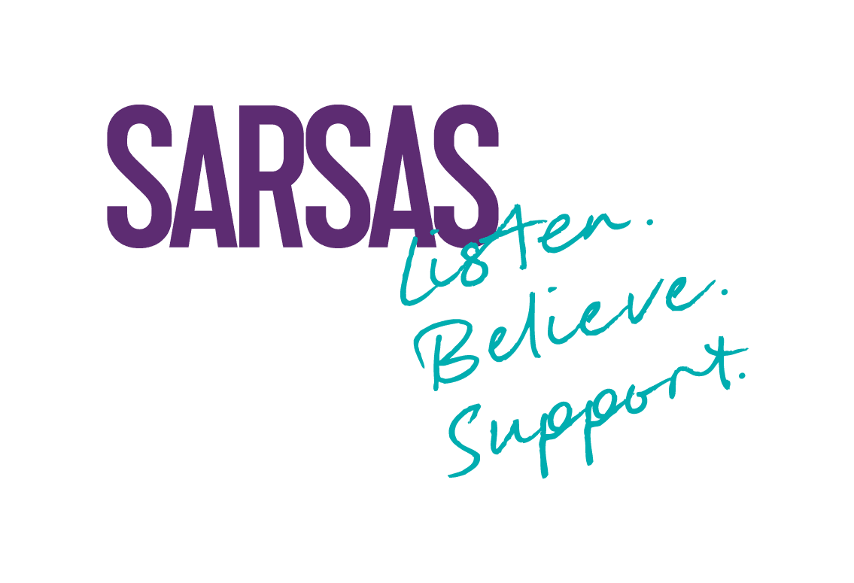
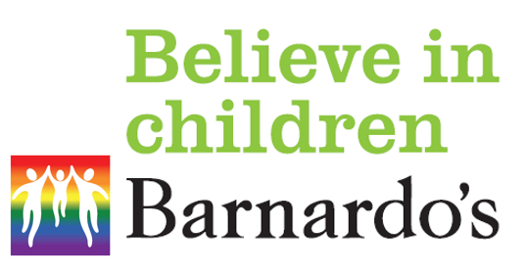


Somerset Phoenix Project
Self-request for Children & Young People

Please use this form if you are requesting support for yourself.
If this form feels too much or you don’t have a way to complete it – don’t worry! We can help you! You can call/text us on 07590 627693 or email us on somersetphoenixproject@barnardos.org.uk.
Consent

I am referring myself to the Somerset Phoenix Project  (Delete the answer that doesn’t apply) | Yes  No
Is this the first time you have been referred to the Somerset Phoenix Project? (Delete the answers that don’t apply) | Yes  No  Not sure
Is this the first time you have told anyone about your abuse?  (Delete the answer that doesn’t apply) | Yes  No
If you have told someone, who did you tell?
If you have told someone, when did you tell them? (We just need your best guess – don’t worry about giving an exact date)

Your Information

First name: |  |  |  |  | Last name:
Age: |  |  |  |  | Date of birth:
Gender identity: |  |  |  |  | Sex assigned at birth:
Sexual orientation: |  |  |  |  | Religion/belief:
Ethnicity:
Disabilities/allergies/special educational needs:
(including physical, learning, sensory, communication or other needs)
Your address:
You need to live in Somerset to get support from Phoenix
Phone numbers:
Email:
Put a ‘x’ if Phoenix can… | Call |  | Text/  WhatsApp |  |  | Email |  | Post to your address |  |  | Leave a voicemail
Preferred way for us to contact you?
Name of school/college
(even if you aren’t going at the moment)
Name of GP surgery (& your GP if you know their name)

Background
Are you involved with CAMHS (Child and Adolescent Mental Health Service)?  (Delete the answers that don’t apply) | Currently.  In the past.  Waiting to hear from them.  No.
Is there a current court case or police investigation?  (Delete the answers that don’t apply) | Yes  No  Don’t know/not sure
Are you safe (no longer experiencing sexual abuse)? (Delete the answer that doesn’t apply) | Yes  No
When did the abuse stop?
(month & year)
What relationship did the person who hurt you have to you?
(For example, parent/grandparent/partner/sibling/someone online/someone at school)

Family issues
We understand that life can be tough, and you might have gone through all sorts of challenges. Please mark with an ‘x’ all that apply to you.

Experienced physical neglect/abuse |  | Have a sibling with a disability
Experienced emotional neglect/abuse |  | Experienced fear about where you are going to live/housing instability
Witnessed your parent/carer struggling with their mental health |  | Experienced bullying
Bereavement/loss of someone close to you |  | Experienced your family having money worries/financial struggles
Witnessed or experienced domestic abuse (including physical, emotional, financial, sexual, coercive) |  | Unemployment in your family
Had your parent/carer go through separation or divorce |  | Parents/carers with disabilities
Had a member of your family go to prison |  | Been a young carer for your parent/carer/family member
Witnessed your parent/carer regularly taking drugs or alcohol that stops them caring for you properly |  | Been adopted or looked after by family members other than your birth parents
Experienced female genital mutilation  (Changes or cuts to a girl’s genitals) |  | Other  (We can talk about this when you are ready)

Trauma Symptoms
Please put a ‘x’ in all the boxes that you experience.
Be as honest as you can; we will not judge you.
All the symptoms below are normal considering the trauma you have been through.

Feeling angry |  | Being overly compliant - saying yes to everything, even when you don’t want to
Struggling to go to sleep/stay asleep |  | Using the toilet more than usual for you
Anxiety/panic attacks/worry |  | Finding it hard to keep yourself clean – this might include showering, brushing your teeth, washing your hair etc
Having low mood/feeling depressed |  | Feeling you have gone backwards –  feeling much younger emotionally
Struggling to eat |  | Struggling with your body image –  Thinking negatively about how you look
Using self-injury/harm to cope with emotional pain |  | Having bodily or verbal tics
Thinking about ending your life |  | Experiencing poor memory/concentration
Trying to end your life |  | Hoarding/collecting lots of ‘stuff’
Having lots of nightmares |  | Having poor family relationships
Having flashbacks in the daytime –  Thoughts or images of what happened popping into your mind when you don’t want them to |  | Afraid to be anywhere near men/women/people who remind you of the person who hurt you
Getting into relationships that aren’t healthy/make you feel good |  | Trying to gain/keep control over lots of things
Feeling like you are telling lots of lies |  | Showering/bathing/washing more than usual for you
Struggling to be apart from the person you are closest to |  | Spending a lot of time in your room/alone - more than you used to
Wanting to watch lots of porn |  | Taking alcohol/drugs or both, to cope with emotional pain
Going missing from home/school/safety for periods of time |  | Been in hospital for mental health reasons
Stealing money or items |  | Been excluded from school
Struggling to leave your safe place/agoraphobia |  | Feeling guilt/shame a lot of the time –  Abuse is NEVER your fault!
Struggling to get into and stay in school/college/work |  | Wetting the bed

If there is anything else you want to tell us about how you are acting or how you are feeling, you can list them here: (you don’t need to tell us the details of what happened to you)
What support have you had before coming to Phoenix?

Other agencies & professionals involved in supporting you
For example, someone in school/college, social worker, drug & alcohol worker etc
(don’t worry if you don’t know all their details)
Name of Professional | Email and telephone details | Agency & Job Role

What kind of support would you like?
We offer a variety of different services to support survivors of sexual abuse.
You can read about our different types of support using the link below.
We can’t promise to offer what you would like but we want to think about what you feel would be best for you.
What support is available? - Somerset Phoenix Project
Professional consultation (1-18 yrs.)
We can give a professional you already know, the support & advice they need to support you in your recovery journey.

Direct specialist support (1-18yrs)
One of our team can give you specialist, trauma-informed, therapeutic support.
This can be at our office or out in the community/school or in any safe & confidential space.

Counselling (13yrs +)
This is held at the nearest counselling space to you!
Our wonderful partners at SARSAS deliver this support but we set it all up with them for you!

Returning the form & what happens next
Sending in your form:
Please try and make sure all the boxes are complete before sending the form.
Please then email the form to:
somersetphoenixproject@barnardos.org.uk

What happens next?
We will let you know (by email) that we have received your form.
We might ask to contact you by phone, email or through messaging if we want to chat things through with you a bit more. We are a friendly bunch & will NEVER ask you to talk about what happened to you, unless you want to tell us & then we will ALWAYS listen.
Every request for support will be considered at a Triage meeting - don’t worry, this is a confidential meeting between some of our team & we just talk about what we can offer that might be the best option for you!
Triage meetings occur on the 1st and 3rd Tuesday of each month.
Once the request for support has been considered at Triage, someone from our team will contact you with the outcome.

We know that reaching out for support can be hard – you have taken a massive step in trusting us! Thank you!
We won’t share your information with anyone unless you have told us something that makes us worried that you are currently in danger or someone you care about is in danger, or you/they might be soon.
If we do need to tell someone else (like a parent/carer, police, social care), we will ALWAYS try & talk with you about this first.

